FLOWCHART:

|  |  |  |
| --- | --- | --- |
|  |  |  |

* Flowchart A graphical representation of the logic for the problem solving.
* The purpose of the flowchart is making the logic of the program in a visual representation
* Flowcharts is a diagram made up of boxes, diamonds, and other shapes, connected by arrows.
* Each shape represents a step-in process and arrows show the order in which they occur.

|  |  |
| --- | --- |
|  | OVAL – TERMINAL SYMBOL |
|  | Parallelogram - Input/ Output symbol |
|  | Rectangle - Process symbol |
|  | Diamond - Decision symbol |
|  | Arrow lines - Flow lines |
|  | To represent a function |
|  | Circle - Connector |

TOOLS USED TO DRAW FLOWCHART

1. **Smart Draw –** A good tool to draw and understand but can’t save the file in system it

can be used for free up to 7 days after that we must pay to use it.

1. **Canva –** A user-friendly tool which allows the user to view in mobile using the application and can be saved in any format. Without even subscription all the features were available.
2. **App.Diagrams.net -** The diagrams can be saved and also at any destination you want it to be. But the Output Wasn’t precise and not in single page the saved diagrams open up to the website.
3. **Lucidchart -** The diagrams can be directly stored into the system and has all the features and also easy to use. It is required to be paid after some uses .
4. **Visme –** The tool is used for flowchart animation and content creating and in teaching, but more tools are available when you pay for them.
5. **Zenflowchart –** The diagrams can be directly stored into the system and has all the features and also easy to use. But it restricts to use more than 20 shapes on using the 21st shape it must be paid.
6. **Visual Paradiagram –** Visual paradiagram is explicitly designed for flowchart drawing, it is also paid one to use but in complex algorithm cases it is the best
7. **Creatly –** This tool is used to design Unified Modeling Language (UML) and flowcharts.
8. **Google Draw –** All the features are available and they are directly stored in the Google Drive. It should be logged in using Email. But the page size was limited also typing the algorithm wasn’t comfortable.

# Exp No: 1- A STUDENT GRADE ANALYSIS

**Date: 29/ 11/22**

# Aim:

To draw flowchart and write algorithm for the following problem.

# ALGORITHM:

**STEP 1:** Start.

**STEP 2:** Get the Number of students (N) **STEP 3:** Assign i

= 0.

**STEP 4:** Check for the condition i < N.

* 1. **:** If True, Get Name, Roll.no and Marks m1, m2, m3, m4, m5.
  2. **:** Calculate Total = m1 + m2 + m3 + m4 + m5 and Average = Total / 5
  3. **:** Display Name and Roll Number.
  4. **:** Check for condition avg >= 30 and avg < 50.
     1. **:** If True Display the message your grade is C" and increase i value by 1.
  5. **:** Check for condition avg > 50 and avg < 80
     1. **:** If True Display the message "You grade is B" and increase i value by 1.
  6. **:** Check for the condition avg > 80 and avg ≤ 100
     1. **:** If True Display the message. "Your grade is A" and increase i value by 1.
  7. **:** Check for the condition avg < 30
     1. **:** If True Display the message "Your grade is D". **STEP 5:** If False, goto step 9

**STEP 6:** Stop.

START GET n

INITIALIZE i=0 IF i > n THEN

GET name, Roll no, m1, m2, m3, m4, m5 CALCULATE Total = m1+m2+m3+m4+m5

Average = Total /3 PRINT name , Roll no

IF avg >= 30 and avg < 50 THEN PRINT Your grade is C

ELIF avg > 50 and avg < 80 PRINT Your grade is B

ELIF avg > 80 and avg ≤ 100

PRINT Your grade is A ELIF avg < 30

PRINT Your grade is D

ENDIF ENDIF i=i+1 STOP

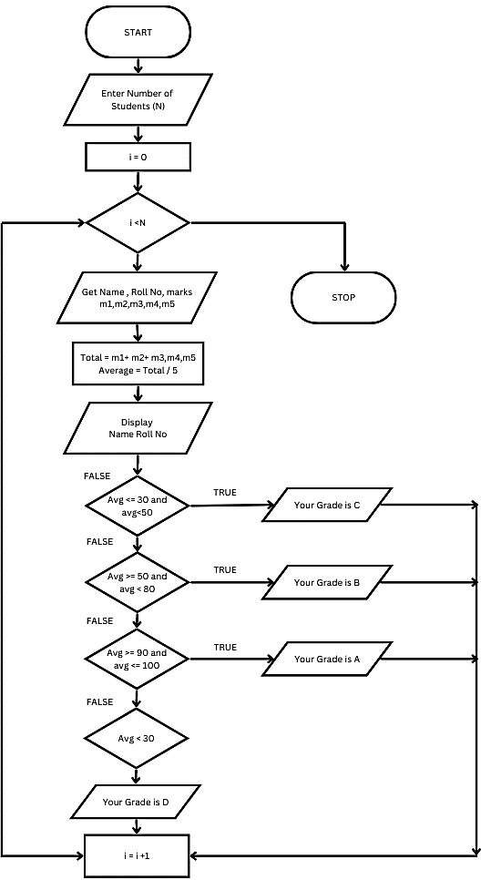

# RESULT:

Thus, the algorithm and flowchart are written for the given problem.

# Date: 29/ 11/22

**AIM:**

To draw flowchart and write algorithm for calculating the electric bill.

# ALGORITHM:

**STEP 1:** Start.

**STEP 2:** Enter Current Unit (CU).

**STEP 3:** Enter Old Unit (OU).

**STEP 4:** Calculate N = CU - OU

**STEP 5:** Check for the condition N<=100 If true.

* 1. : Calculate E.C using formula. FC = 0, DC = 0, EC= 0
  2. **:** Calculate the Total charges = FC + DC + EC
  3. **:** Display Total charges and go to Step 7.

**STEP 6:** Check for condition N<=200 If true.

* 1. : Calculate E.C using formula FC = 20, DC = 18, EC = (N – 100) * 1.5
  2. **:** Calculate the Total charges = FC + DC + EC
  3. **:** Display Total charges and go to Step 7.

**STEP 7:** Check condition N<=500 of take.

* 1. **:** Calculate EC using formula. FC = 73, DC = 48, EC = ( N - 100) * 3.5
  2. **:** Calculate the Total charges = FC + DC + EC
  3. **:** Display Total charges and go to Step 7.

**STEP 5:** Check for the condition N>500 If true.

**5.1:** Calculate the E.C using FC=75, DC=100, EC = (400 * 4.5) + (N - 500) * 6

* 1. **:** Calculate Total charges = FC + DC + EC
  2. **:** Display the Total charges and go to Step 7.

**STEP 7:** Stop.

START GET CU GET OU

CALCULATE N=CU-OU IF N<=100 THEN

FC = 0, DC = 0, EC= 0 CALCULATE EC

ELIF N<=200 THEN

FC = 0, DC = 0, EC= 0 CALCULATE EC = (N – 100) * 1.5

ELIF N<=500 THEN

FC = 0, DC = 0, EC= 0 CALCULATE EC = ( N - 100) * 3.5

ELIF N>500 THEN

FC = 0, DC = 0, EC= 0

CALCULATE EC = (400 * 4.5) + (N - 500) * 6

ENDIF

PRINT Total Charges = FC + DC + EC STOP

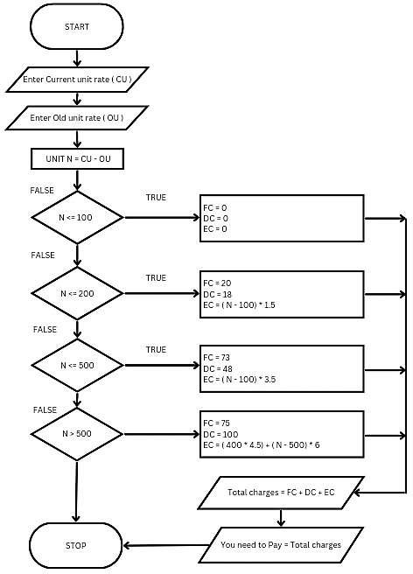

# RESULT:

Thus, the algorithm and the flowchart is written for the given problem.

# Date: 29/ 11/22 AIM:

To draw flowchart and write algorithm for calculating the weight of a steel Rod.

# ALGORITHM:

**STEP 1:** Start.

**STEP 2:** Get the number of Iron rods.

**STEP 3:** Initialize the value I and weight as 0.

**STEP 4:** Check for the condition i = n.

* 1. **:** If True, get the diameter of the rod.
  2. **:** Calculate the weight-unit-weight using the formula d*2 /162 = W
  3. **:** Calculate the weight using the formula. Tw = No. of rods * weight
  4. **:** Calculate total weight = TW+W.
  5. **:** Increment the value of i by 1 goto step 4.

**4.1:** If false display the total weight.

**STEP 5:** Stop

START GET n

INITIATE i=0, Weight=0 IF i = n THEN

GET d

CALCULATE W = d*2 /162 CALCULATE Tw = Tw + W i=i+1

ELSE

PRINT Tw ENDIF STOP

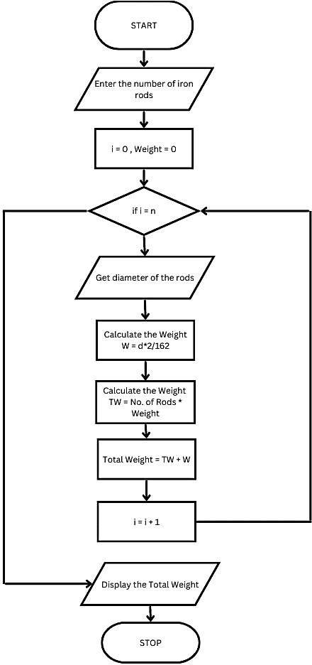

# RESULT:

Thus, the algorithm and the flowchart is given for the problem.

# Date: 29/ 11/22

**AIM:**

To draw flowchart and write algorithm for calculating weight of a motorbike.

# ALGORITHM:

**STEP 1:** Start.

**STEP 2:** Get gross vehicle weight Rating GVWR

**STEP 3:** Get Dry weight (DW) **STEP 4:** Get Fuel weight (FW) **STEP 5:** Get Raider weight (RW) **STEP 6:** Get Passenger weight (PW)

**STEP 7:** Calculate Total weight = DW+FW+RW+PW **STEP 8:** Get Load.

**STEP 9:** Calculate Load Weight = Total Weight + Load **STEP 10:**

Calculate Safe Weight = GVWR – Load Weight **STEP 11:** Check the condition safe weight >=0.

* 1. **:** If true, print the message “You have a safe load and you can drive" goto stop.
  2. **:** If false, print the message "Reduce the load and then drive”.
     1. **:** GOTO step 8.

**STEP 12:** Stop.

START GET GVWR GET DW GET FW GET RW GET PW

CALCULATE Total Weight = DW + FW+ RW + PW

GET Load

CALCULATE Load Weight = Total Weight + Load CALCULATE Safe Weight = GVWR = Load Weight IF Safe Weight >= 0 Then

PRINT You have a safe load and you can drive

ELSE

ENDIF STOP

PRINT You have excess weight, Reduce the load and then drive

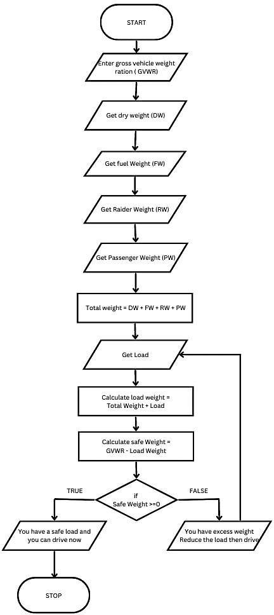

# RESULT:

Thus, the flowchart and the algorithm is written for the problem.

# Exp No: 1- E Date: 29/ 11/22

**CALCULATE ELECTRIC CURRENT IN**

# 3 PHASE A/C CIRCUIT

**AIM:**

To draw flowchart and write algorithm. to- calculate electrical current in 3 phase AC circuit.

# ALGORITHM:

**STEP 1:** Start

**STEP 2:** Get value of pf (power factor) **STEP 3:** Get value of Current (I).

**STEP 4:** Get value of voltage (V)

**STEP 5:** Calculate P using the formula P= √3*pf*I*V. **STEP 6:**

Display the value of P.

**STEP 7:** Stop

START GET Pf GET I GET V

CALCULATE P = 1.732 * I * V PRINT P

STOP

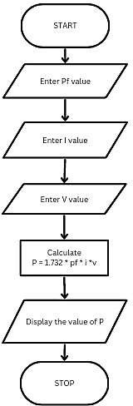

# RESULT:

Thus the flowchart and the algorithm is written for the given problem.

# Date: 29/ 11/22

**AIM:**

To draw the flowchart and write the algorithm for the retail shop billing.

# ALGORITHM:

**STEP 1:** Start

**STEP 2:** Get the Bill number.

**STEP 3:** Get costumer Customer name and phone number **STEP 4:** Get the value of total No. of Items purchased.

**STEP 5:** Initialize the values for i =0, Total =0, Net Amount = 0 and Gross=0.

**STEP 6:** Check if condition i<=n.

* 1. **:** If true, get Item name, Price, Quantity and the discount.
  2. **:** Calculate the Gross = Price * quantity Calculate the Disc = Gross * Discount%

Calculate the Net Amount = Gross-Disc **6.3:** Calculate the Total = Total + Net Amount. **6.4:** Increment the value of i and goto step 6.

**STEP 7:** If False, get the GST value.

**STEP 8:** Calculate GST Amount = ( Gross * GST% ) / 100.

Calculate the BILL Price = Net Amount + GST Amount **STEP 9:** Display the Bill Amount **STEP 10:** Stop.

START

GET Bill Number

GET custoumer name , number

INITIALIZE i=0, Total=0, Net Amount=0, Gross=0 IF I<=n

GET Item Name, Price, Quantity, Discount

CALCULATE The Gross = Price * quantity CALCULATE The Disc = Gross * Discount% CALCULATE The Net Amount = Gross-Disc

CALCULATE the Total = Total + Net Amount i=i+1

ELSE

GET GST

CALCULATE GST AMOUNT = (GROSS * GST%) / 100.

CALCULATE the BILL Price = Net Amount + GST Amount PRINT BILL Price

ENDIF STOP

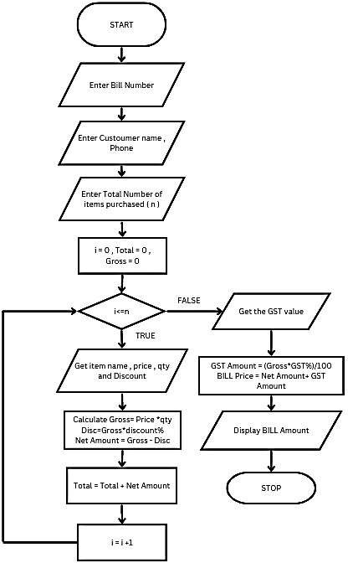

# RESULT:

Thus, the flowchart and the algorithm is written for the problem

# Date: 29/ 11/22

**AIM:**

To draw flowchart and write algorithm for the sine series.

# ALGORITHM:

**STEP 1:** Start.

**STEP 2:** Get the value of x.

**STEP 3:** Initialize the values of 1=1, sine =0 and import math.

**STEP 4:** Get the value of N.

**STEP 5:** Check weather value does i less than N

* 1. **:** If condition is true, calculate y = y + x ( 3.416 % 100 )
     1. **:** Let value of s be (-1) to the power i
     2. **:** Now calculate the series using the formula.

Sine = sine + ((y**2* i +1))/ math factorial (2*i*1) S.

* + 1. **:** Increment value of i by 1.
  1. : If condition is false display sine.

**STEP 6:** Stop.

START GET x

INITIALIZE i=1,sine=0

IMPORT math GET n

IF i < n

ELSE

PRINT Sine ENDIF STOP

CALCULATE y = y + x ( 3.416 % 100 ) ASSIGN s = (-1) ** i

CALCULATE Sine = sine + ((y**2* i +1))/ math factorial (2*i*1) S. i=i+1

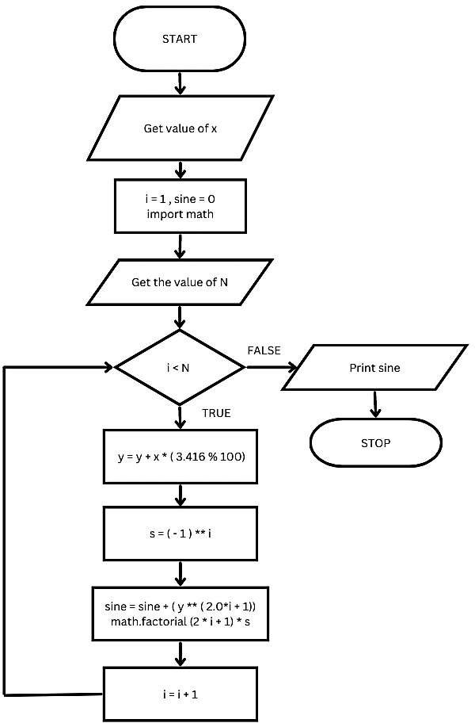

# RESULT:

Thus, the flowchart and the algorithm is written for the problem